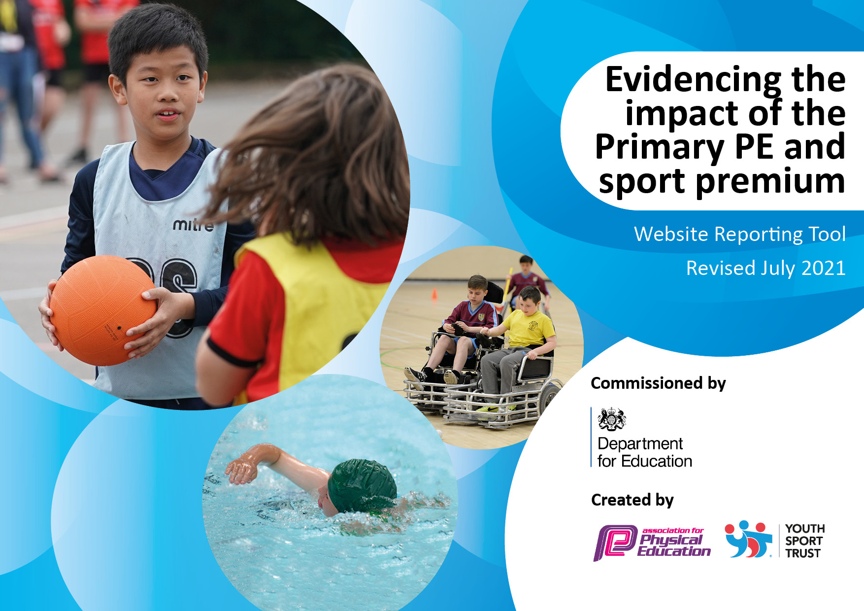
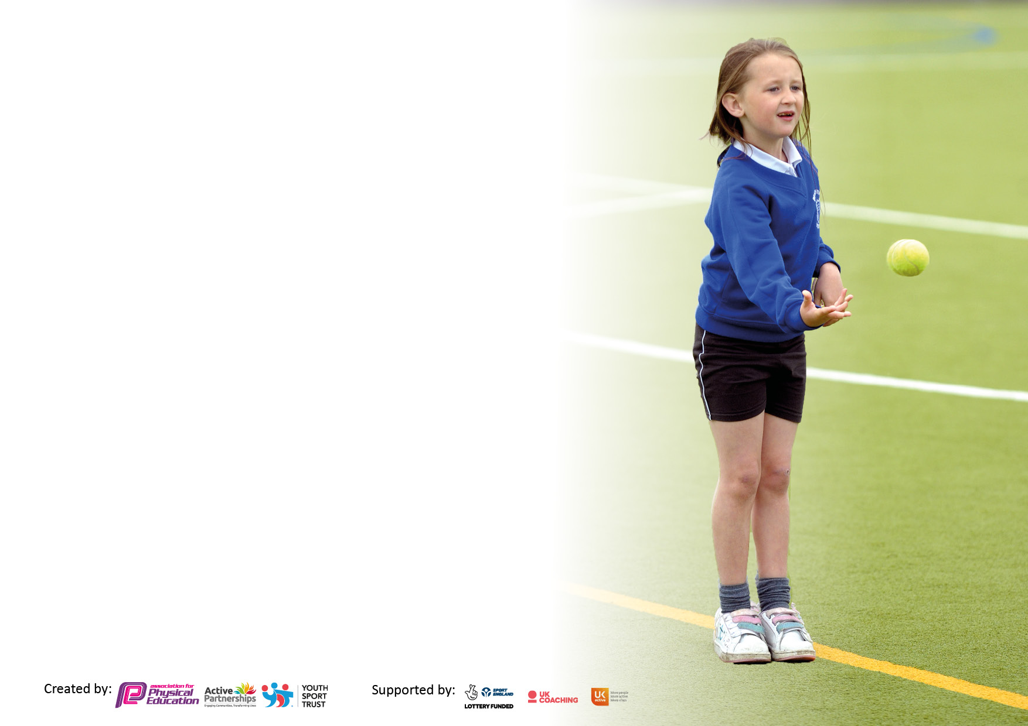

It is important that your grant is used effectively and based on school need. The Education Inspection Framework makes clear there will be a focus on ‘whether leaders and those responsible for governors all understand their respective roles and perform these in a way that enhances the effectiveness of the school’.

Under the Quality of Education Ofsted inspectors consider:
Intent - Curriculum design, coverage and appropriateness
Implementation - Curriculum delivery, Teaching (pedagogy) and Assessment
Impact - Attainment and progress

To assist schools with common transferable language this template has been developed to utilise the same three headings which should make your plans easily transferable between working documents.

Schools must use the funding to make additional and sustainable improvements to the quality of Physical Education, School Sport and Physical Activity (PESSPA) they offer. This means that you should use the Primary PE and sport premium to:

- Develop or add to the PESSPA activities that your school already offer
- Build capacity and capability within the school to ensure that improvements made now will benefit pupils joining the school in future years
- The Primary PE and sport premium should not be used to fund capital spend projects; the school’s budget should fund these.

Pleasevisitgov.ukfortherevisedDfEguidanceincludingthe5keyindicatorsacrosswhichschoolsshoulddemonstrate animprovement.Thisdocumentwillhelpyoutoreviewyourprovisionandtoreportyourspend.DfEencouragesschools to use this template as an effective way of meeting the reporting requirements of the Primary PE and sport premium.

We recommend you start by reflecting on the impact of current provision and reviewing the previous spend.

Schools are required to publish details of how they spend this funding, including any under-spend from 2019/2020, as well as on the impact it has on pupils’ PE and sport participation and attainment. All funding must be spent by 31st July 2022.

We recommend regularly updating the table and publishing it on your website throughout the year. This evidences your ongoing self-evaluation of how you are using the funding to secure maximum, sustainable impact. Final copy must be posted on your website by the end of the academic year and no later than the 31st July 2021. To see an example of how to complete the table please click HERE.
Created by: Supported by:

Details with regard to funding
Please complete the table below.

Total amount carried over from 2019/20 | £ -
Total amount allocated for 2020/21 | £ 17, 420
How much (if any) do you intend to carry over from this total fund into 2021/22? | £12, 948.00
Total amount allocated for 2021/22 | £17, 420
Total amount of funding for 2021/22. To be spent and reported on by 31st July 2022. | £30,368.00
Swimming Data
Please report on your Swimming Data below.

Meeting national curriculum requirements for swimming and water safety.

N.B. Complete this section to your best ability. For example you might have practised safe self-rescue techniques on dry land which you can then transfer to the pool when school swimming restarts.
Due to exceptional circumstances priority should be given to ensuring that pupils can perform safe self rescue even if they do not fully meet the first two requirements of the NC programme of study
What percentage of your current Year 6 cohort swim competently, confidently and proficiently over a distance of at least 25 metres?  N.B. Even though your pupils may swim in another year please report on their attainment on leaving primary school at the end of the summer term 2021.  Please see note above | 45%
What percentage of your current Year 6 cohort use a range of strokes effectively [for example, front crawl, backstroke and breaststroke]?  Please see note above | 45%
What percentage of your current Year 6 cohort perform safe self-rescue in different water-based situations? | 100%
Schools can choose to use the Primary PE and sport premium to provide additional provision for swimming but this must be for activity over and above the national curriculum requirements. Have you used it in this way? | Yes/No

Action Plan and Budget Tracking
Capture your intended annual spend against the 5 key indicators. Clarify the success criteria and evidence of impact that you intend to measure to evaluate for pupils today and for the future.

Academic Year: 2020/21 | Total fund allocated: | Date Updated:
Key indicator 1: The engagement of all pupils in regular physical activity – Chief Medical Officers guidelines recommend that primary school pupils undertake at least 30 minutes of physical activity a day in school |  |  |  | Percentage of total allocation:
 |  |  |  | %
Intent | Implementation |  | Impact
Your school focus should be clear what you want the pupils to know and be able to do and about  what they need to learn and to  consolidate through practice: | Make sure your actions to achieve are linked to your intentions: | Funding allocated: | Evidence of impact: what do pupils now know and what can they now do? What has changed?: | Sustainability and suggested next steps:
Ensure children have 60 minutes of being physically active - increase physical activity levels and engagement. To ensure active lunchtime opportunities for all children are embedded. Ensure that equipment is readily available for all children at play times and lunch times to encourage daily activity. | - Conduct an audit of lunchtime resources and order new equipment.  - Playground leaders to lead games with KS1 children.  - A wide and varied range of activities to be on offer  - Create a timetable/rota of activities  - Purchase storage box for equipment to be stored in for easy access by children at playtimes and lunch time. | £4052.25 | - Lunchtime resources are accessed by all children  - Increased levels of engagement from less active children  - Lunchtimes are active  - Less incidents of children falling out  - Positive attitudes towards healthy and active lifestyles are embedded. | Continue to audit playtime equipment.  Encourage children to use equipment at playtime through playground leaders. Look into playground leader training for both welfare staff and children.
Key indicator 2: The profile of PESSPA being raised across the school as a tool for whole school improvement |  |  |  | Percentage of total allocation:
 |  |  |  | %
Intent | Implementation |  | Impact
Your school focus should be clear what you want the pupils to know and be able to do and about  what they need to learn and to  consolidate through practice: | Make sure your actions to achieve are linked to your intentions: | Funding allocated: | Evidence of impact: what do pupils now know and what can they now do? What has changed?: | Sustainability and suggested next steps:
Ensure there are specific and sufficient resources and high-quality equipment to allow children to access the curriculum at their physical competency level to develop their skills and allowing teachers to deliver effective lessons. | - Purchase extra resources and equipment where needed – carry out equipment audit. | Included in costing above. | - Children are able to select from a range of equipment that meet their stage of development to perform skills in different activity areas.  - Standards are being met at the end of each key stage in relation to relevant aspects of PE.  - Staff more confident to deliver PE sessions knowing that lessons can be resourced. | Look in to purchasing new equipment to help deliver pe lessons where needed – netball posts, reception climbing frame and balance bikes.
Continue to offer opportunities for children to access after school clubs – an increase in % reported term on term from targeted offers. Opportunities for ALL children to take part PP, SEN focus. | Buy into Little Lions  - 2 x weekly Lunch times clubs - opportunities for house v house sport competitions.  - 2 x weekly After school clubs  - South Ribble to offer after school club for a half term. | £8877.50 | - Increased number of pupils participating in after school club opportunities and reporting increased enjoyment in these. | Invite local clubs to come in to deliver afterschool clubs.  Continue to target groups of children who are less active.

Key indicator 3: Increased confidence, knowledge and skills of all staff in teaching PE and sport |  |  |  |  | Percentage of total allocation:
 |  |  |  |  | %
Intent | Implementation |  | Impact
Your school focus should be clear | Make sure your actions to | Funding | Evidence of impact: what do |  | Sustainability and suggested
what you want the pupils to know | achieve are linked to your | allocated: | pupils now know and what |  | next steps:
and be able to do and about | intentions: |  | can they now do? What has
what they need to learn and to |  |  | changed?:
consolidate through practice:
To provide PE CPD to all teaching staff, derived from audit to increase staff confidence and ability to lead PE and improve knowledge and understanding.  - Teaching high quality dance and gymnastics activities at KS1  - Teaching high quality dance and gymnastics activities at KS2  - Getting to grips with KS2 PE | - Staff given time where appropriate to use knowledge from courses to any make resources and feedback relevant information from courses in staff meetings.  - Monitor quality of teaching and learning in PE in relation to courses attended | £585 | KS1 course cancelled  TA attended KS2 Getting to grips with PE course.  KS2 teacher attended Dance and gymnastics course and fed back. |  | KS1 course to be booked for next academic year.  KS2 course to be booked for TA and teachers delivering PE.  Staff audit at start of year to identify any further gaps in knowledge and understanding of PE areas.
To ensure all staff are able to deliver high quality PE lessons with clear skill based focus. Ensure that assessment is being used effectively | - Buy into the Lancs APP Pe scheme to help support staff with planning and development. (26th May - course) The ability to input assessment more easily will help aid and inform planning.  - Monitor through planning, lesson observations, learning walks questionnaires, pupil voice. | £484 | - Pupils can feedback about their enjoyment of lessons and can talk about the skills they have learnt – Y1 trail in Summer 2 term |  | September 2022 Lancs consistent to deliver App training to all staff. (£395) Monitor assessment is being used and being used effectively to aid pupils. (£200 x 6)
Key indicator 4: Broader experience of a range of sports and activities offered to all pupils |  |  |  |  | Percentage of total allocation:
Intent | Implementation |  | Impact
Your school focus should be clear | Make sure your actions to | Funding | Evidence of impact: what do |  | Sustainability and suggested
what you want the pupils to know | achieve are linked to your | allocated: | pupils now know and what |  | next steps:
and be able to do and about | intentions: |  | can they now do? What has
what they need to learn and to |  |  | changed?:
consolidate through practice:
To continue to offer a wider range of activities both within and outside the curriculum in order to get more pupils involved in physical activity and providing them with a variety of experiences/skills and sporting opportunities. To provide a wide range of cycling opportunities for pupils throughout the school. | ✓ South Ribble to offer after school club for a half term.  ✓ Buy into SRBC for active school clubs ✓ Dance from the Heart ✓ Scootsafe – Year 3 ✓ Tots Level 1 and 2 Spring term ✓ Bikeability – Year 5/6 ✓ Bike Fix – Year 5/6 | £1825 | Buy into Little Lions  - 2 x weekly Lunch times clubs - opportunities for house v house sport competitions.  - 2 x weekly After school clubs  - South Ribble to offer after school club for a half term.  - Purchase extra resources and equipment where needed – carry out equipment audit.  - Increased attendance at after school clubs with some children attending more than one club  Pupils able to use a wide range of skills |  | - research cross curricular orienteering pack for school  - Continue to buy into `SRBC to deliver after school clubs as well as creating links with local sporting clubs to deliver clubs.
Introduce Forest schools to help develop the whole child (character values) and provide children with new opportunities to learn new skills.  Children to develop fine and gross motor skills within forest school setting. | ✓ Purchase equipment to develop forest school setting  ✓ Create timetabled sessions for classes once 3 members of staff are level 3 qualified.  ✓ Purchase resources to develop forest schools and gross motor skills for reception and KS1 children. | £6117.50  £6244.37 |  | - Use the outdoor environment to encourage and inspire children to grow in confidence, independence and self-esteem through the mastery of small, achievable tasks.  - Children will develop their understanding of how to deal with their emotions and also developing life skills such as trust, respect, teamwork and communication  - KS1 children developing the motor skills while accessing the forest school setting.

Key indicator 5: Increased participation in competitive sport |  |  |  | Percentage of total allocation:
 |  |  |  | %
Intent | Implementation |  | Impact
Your school focus should be clear | Make sure your actions to | Funding | Evidence of impact: what do | Sustainability and suggested
what you want the pupils to know | achieve are linked to your | allocated: | pupils now know and what | next steps:
and be able to do and about | intentions: |  | can they now do? What has
what they need to learn and to |  |  | changed?:
consolidate through practice:
To continue to allow children to experience competition into different forms.  • inter-house competitions. • participation in external sporting events. • opportunities for children to apply skills learnt in lessons and clubs. | Buy into Little Lions ✓ 2 x weekly Lunch times clubs - opportunities for house v house sport competitions and target those children who do not attend after school clubs. ✓ 2 x weekly After school clubs | £ included in Little Lions costing  £ (South Ribble after school club costing) | - Pupils’ have access to a broad range of sporting activities available including the KS2 inclusion events that they may not otherwise experience.  - Pupils enjoy participating and it enhances their understanding of sports participation and increases the likelihood that they will continue to take part.  - Pupils’ achievements are celebrated | Continue to buy into sports competitions with SRBC.

Signed off by
Head Teacher:
Date:
Subject Leader: | - Baron
Date: | July 2022
Governor:
Date:

