The Bible Scavenger Hunt
Use a bible, or look online, and see if you can answer these…

The last book of the bible:
The book after Daniel:
The first book of the New Testament:
The first word in the bible:
The last book in the bible:
The first book named after a woman:
The 20th book of the bible:
The second book named after a woman:
The book before Jonah:
The last book of the Old Testament:
The book with the shortest name:
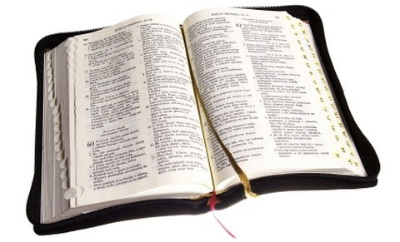
The second book of the Old Testament

