Scorpions Home Learning Week 2
English – GPS week  All groups - Relative clauses | Maths  All group – Times Table Rock Stars | PE  Visit the go noodle website and have a go at some of the different activities – there’s loads to choose from.  This is a good dancing one:  https://family.gonoodle.com/activities/i-gotta-feeling | 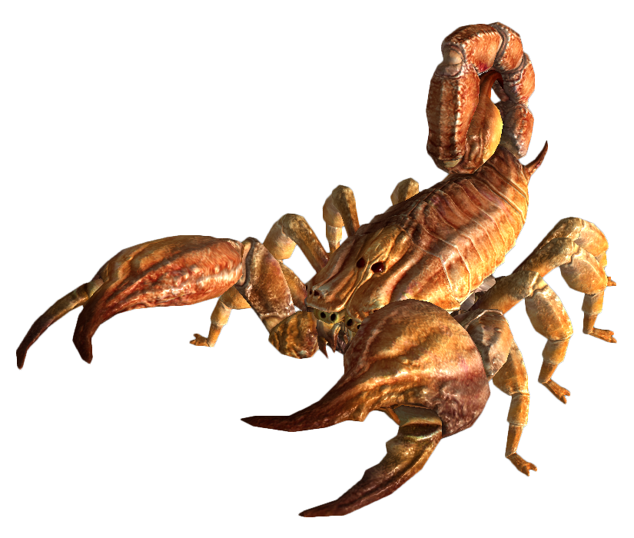  RE  Books of the Bible scavenger hunt – 2 to choose from.
English  Groups 1 and 2 - Modal verbs  Group 3 – Correct the spelling | Maths  Groups 1 and 2 - square and cube numbers.  Group 3 – number bonds to 10, 20 and 100 | French  Using the attached files for ideas, create and decorate a menu for a French café. This can be done on paper or a computer. | Geography  Capitals and countries  See attached sheets – there are lots to try.
English  Types of phrases  Group 3 – GPS challenge cards | Maths  All groups – Maths Shed games | PE  Complete a Joe Wicks video on YouTube  https://www.youtube.com/watch?v=Rz0go1pTda8 | History  Anne Frank secret annex activity.
English  All groups - Conjunctions | Maths  Groups 1 and 2 - prime numbers  Group 3 – online games | Art  Drawing an optical illusion hand.  https://www.youtube.com/watch?v=YNEXzvnD7mI | PSHE  Turn a negative into a positive
English  Up-levelling sentences. | Maths  Groups 1 and 2 – telling the time  Group 3 – months of the year | Science  How to grow a rainbow – see attached sheet. | ICT  Use your password to access the Scratch website. See if you can make a simple game.

