



**Relational**

**(Behaviour)**

**Policy**

**2023**

*1*



**St Aidan’s CE Primary School**

**Our Vision**

At St Aidan’s we believe that, in order to facilitate teaching and learning, acceptable behaviour must be demonstrated in all aspects of school life. The school is committed to:

* Promoting desired behaviour.
* Promoting self-esteem, self-discipline, proper regard for authority, and positive relationships based on mutual respect.
* Ensuring equality and fair treatment for all.
* Praising and rewarding good behaviour.
* Challenging and disciplining misbehaviour.
* Providing a safe environment free from disruption, violence, discrimination, bullying and any form of harassment.
* Encouraging positive relationships with parents.
* Developing positive relationships with pupils to enable early intervention.
* A shared approach which involves pupils in the implementation of the school’s policy and associated procedures.
* Promoting a culture of praise and encouragement in which all pupils can achieve.

**Policy Statement**

St Aidan’s CE Primary School is committed to creating an environment where exemplary behaviour is at the heart of productive learning. Everyone is expected to maintain the highest standards of personal conduct, to accept responsibility for their behaviour and encourage others to do the same. Our relational policy guides staff to teach self-discipline not blind compliance. It echoes our core values with a heavy emphasis on respectful behaviour for all and a partnership approach to managing poor conduct through emotion coaching.

**Policy Aim**

* To promote an ethos within which children and staff seek to achieve the highest possible standards of learning and teaching.
* To bring all members of our school together in a shared approach, following key principles and practices that reflect our school ethos.
* To ensure that all learners are treated fairly and to promote good relationships.
* To refuse to give learners attention and importance for poor conduct.
* To ensure that excellent behaviour is a minimum expectation for all.

Our ethos expresses our motto: **Live, Laugh, Love, Learn**

**Roles and Responsibilities**

Behaviour is a shared responsibility and is part of a learning process for all within our community. Our expectation is for all staff and parents to display exemplary behaviour in all areas and as role-models for our children.

**All staff must**

* Meet and greet children at classroom doors.
* Be consistently calm and regulated.
* Pay first attention to best conduct.
* Refer to ‘safe, respect, ready’ expectations.
* Model positive relationships and build relationships.
* Use a visible recognition board in every classroom.
* Use and discuss ‘zones of regulation’ to embed the vocabulary of emotions.
* Be calm and give ‘take up time’ when going through steps. Prevent before sanctions.
* Follow up every time, retain ownership and engage in reflective dialogue with learners.
* Never ignore or walk past learners who are failing to meet expectations.

**The Headteacher and FSW must:**

* Meet and greet pupils at school gates.
* Be a visible presence around school.
* Support teachers in managing students with more complex or challenging behaviours.
* Use data from CPOMS to target and assess interventions.

**Positive Strategies**

**Recognition Board**

A recognition Board will be used to encourage social or learning behaviours. Children’s names will be moved onto recognition boards when they have exhibited the target behaviour for that day. The aim should always be for the whole class to get on the board. Adults or pupils in the class can nominate names for the board and there is emphasis on children working together as a team to get everyone’s name on the board. A name cannot be removed from the board once it is on. Small celebration once the board is full e.g., Whoop, celebration song, teacher juggles.

*‘This is not intended to shower praise on the individual, it is a collaborative strategy – we are* ***one team*** *focused on* ***one learning behaviour*** *and moving in* ***one direction****.’*

Paul Dix

**Star of the Week Certificate**

The certificate is a high-level recognition for going over and above. Two certificates are awarded by each class teacher every Friday. The certificates are presented in celebration worship and names are shared in the school newsletter.

**100 Square**

Squares are rewarded for any positive behaviour, this can be linked to academic progress, personal qualities etc…

Any member of staff can award up to 5 squares for any one behaviour no matter which class the children are in.

Number square reward winners are drawn every Friday – with a maximum of 3 winners per 100 squares awarded.

**Intervention Steps**

Learners are held responsible for their behaviour. Staff will deal with the behaviour without delegating. We respond to behaviour that fails to meet expectations following these steps. The steps are to be followed in order. They must not be escalated through.

*DO NOT describe the child’s behaviour to others in front of the child. Derogatory language referring to the child and their behaviour is not acceptable. *

**Reminder**

Privately remind the child of our expectations – safe, kind, ready. Repeat reminders if necessary. De-escalate and decelerate where reasonable and possible and take the initiative to keep things at this stage.

**Advice**

Privately outline the behaviour that is failing to meet expectations and what needs to be done to fix it.

**30 Second Intervention**

Speak to the learner privately and give final opportunity to engage through delivering the 30 second intervention script. Use a gentle approach, personal, non-threatening, side on to learner, be at their eye level or lower.

* ***I have noticed that you are*** *(having trouble getting motivated, wandering around playing with…)*
* ***You are not showing our expectation of*** *(safe, kind, ready)*
* ***You have…***
* ***Because of that you need to…*** *(refer to action to support behaviour e.g., move to another table, complete learning another time)*
* ***Do you remember when you*** *(refer to previous positive behaviour)*
* ***That is who I need to see today***
* ***Thank you for listening.***

Walk away from the learner; allow them time to decide what to do next. If there are comments as you walk away, write them down and follow up later.

At St Aidan’s we resist endless discussions around behaviour and spend our energy returning learners to their learning.

Ensure that consequences/fix its used for different behaviours are logical and appropriate.

(Repetitive rhythmic activity, run) Behaviour could be communication of a sensory need.

**Emotion Coaching**

Speak to the learner privately and deliver the script. Use a gentle approach, personal, non-threatening, side on to learner, be at their eye level or lower.

* ***I have noticed that you are*** *(having trouble getting motivated, wandering around playing with…)*
* ***You are not showing our expectation of*** *(safe, kind, ready)*
* ***You have…***
* ***Because of that you need to…*** *(refer to action to support behaviour e.g., walk and talk, class nurture space, outdoor run, repetitive rhythmic activity, complete work in different classroom)*
* ***I will come and speak to you in ten minutes/after break.***

After the child has had their time out of class, have Emotion Coaching conversation with them.

1. **Recognising, empathising, soothing to calm**
   1. Recognise all emotions as being natural and normal and not always a matter of choice.
   2. Recognise behaviour as communication (Relational vs Behavioural Model).
   3. Look for physical and verbal signs of the emotion being felt.
   4. Take-on the child's perspective (Mentalising/Mind-mindedness).
   5. Affirm and empathise, allowing to calm down.
2. **Validating the feelings. Labelling the feelings and linking with emotions.**
   1. Validate the emotion and acknowledge its existence.
   2. Use words to reflect back the child's emotion.
   3. Help the child/young person to label the emotion.
   4. Provide a narrative/translation for the emotional experience (creating cognitive links).
3. **Setting limits on behaviour.**
   1. Safety first.
   2. State the boundary limits of acceptable behaviour.
   3. Make it clear certain behaviours cannot be accepted.
   4. But retain the child's self-dignity (crucial for response behaviour and well-being).
4. **Problem-solving with the young person**

When the child is calm and in a relaxed, rational state:

* Explore the feelings that give rise to the behaviour/problem/incident.
* Scaffold alternative ideas and actions that could lead to more appropriate and productive outcomes.
* Empower the child to believe s/he can overcome difficulties and manage feelings/behaviour.

If the behaviour improves, they child returns to class.

If the behaviour doesn’t improve, move to the next step.

The teacher must decide on a logical, appropriate consequence for the child’s actions. For example, if the situation has resulted in significant leaning time being lost, the teacher may decide work should be taken home to complete (pay it back time).

Log what happened on **CPOMS**

* What behaviour was presented?
* What led up to the behaviour?
* What steps were followed to de-escalate?
* How was the situation followed up?

**Extreme Behaviours**

Some children exhibit particular behaviours based on early childhood experiences and family circumstances. As a school, we recognise that their behaviour is their way of communicating their emotions. We also understand that for many children they need to feel a level of safety before they exhibit extreme behaviours. Where possible, we use our most skilful staff to build relationships with each individual child. These children may have bespoke ‘Positive Handling Plans’ that detail additional support, strategies and expectations.

When dealing with an episode of extreme behaviour, a child may need to be restrained if they or another person is unsafe. This will only be used as a last resort and by experienced, trained staff only. The school will record all incidents of extreme behaviour on CPOMS.

Exclusions will occur following extreme incidents at the discretion of SLT. A fixed-term exclusion will be enforced under these conditions:

* Staff need respite after an extreme incident.
* The child needs time to reflect on their behaviour.
* To give the school time to create a plan which will support the child better.
* The child being at home will have a positive impact on future behaviour.

If these conditions are not met, other options may include a day withdrawal with a member of SLT in another part of the school. We understand that throughout the process, it is imperative that we explain what is happening and why it is happening to parents and arrange meetings to discuss.

**Unacceptable Behaviours**

Occasionally, some children may behave in an extreme way which is out of character for them. Unacceptable behaviours may be expedited through our system in order to be dealt with more quickly by a member of SLT.

These behaviours include –

* Violence (i.e., physical contact made with the intention to harm)
* Defiance
* Persistent taunting, teasing and bullying behaviour
* Stealing
* Spitting
* Swearing
* Biting

**Child on Child abuse**

**Responding to reports**

All reports of Child on Child abuse will be. Made on a case by case basis with the designated safeguarding lead or their deputy taking a leading role using their professional judgement and supported by other agencies such as social care or the police as required.

**The immediate response to report**

The school will take all reports seriously and will reassure the victim that they will be supported and kept safe.

* All staff will be trained to manage a report.
* Staff will not promise confidentiality as the concern will need to be shared further (for example, with the designated safeguarding lead or social care) staff will however only share the report with those people who are necessary to progress it.
* A written report will be made as soon after the interview as possible recording the facts as presented by the child. These may be used as part of a statutory assessment if the case is escalated later.
* Where the report includes an online element the school will follow advice on searching, screening and confiscation. The staff will not view or forward messages unless unavoidable and only if another member of staff (preferably the DSL) is present.
* The DSL will be informed as soon as possible in person.

**Risk Assessment**

When there has been a report of sexual violence, the designated safeguarding lead (or a deputy) will make an immediate risk and needs assessment. Where there has been a report of sexual harassment, the need for a risk assessment should be considered on a case-by-case basis. The risk and needs’ assessment should consider:

* The victim, especially their protection and support;
* The alleged perpetrator; and
* All the other children (and, if appropriate, adults and staff) at the school, especially any actions that are appropriate to protect them.

Risk assessments will be recorded in CPOMS and kept under review. The designated safeguarding lead (or a deputy) will ensure they are engaging with MASH team for advice and guidance.

**Managing Behaviour – Logical Consequences**

**VERBAL WARNING**

(can be more than once - age/event related)

**IN CLASS CONSEQUENCE**

(removed from usual seating place)

**‘TIME OUT’**

(stand next to the staff member on playground duty, isolated from other children in the classroom, or in the shared area- where they can be seen by an adult)

**LOSS OF CHILD’S TIME**

eg discussion with teacher, catch up on work or a set task (staff members’ discretion)

**SECLUSION TO ANOTHER CLASSROOM**

(contact parents/carers) recorded on CPOMs.

**SECLUSION IN HT OFFICE**

(contact parents/carers) recorded on CPOMs.

**MISSING A SIGNIFICANT EVENT**

eg if a trip/theatre group/residential is upcoming then parents/carers are contacted and a personalised letter or phone call from head teacher is sent at this point.

The Senior Leadership Team will monitor the CPOMs regularly and discuss with staff (and parents/carers if necessary) if any trends appear and if necessary, a Behaviour Plan will be written. A referral to the Pastoral Support Team(Learning mentor/FSW and SENCO) could be made at this time.

When no improvement is evident in the timeframe of the behaviour plan, a Behaviour Contract (Appendix 2) is written and signed by pupil, parents/carers and school.

**REFERRAL TO THE INCLUSION HUB FOR SUPPORT**

(PARENTS/CARERS IN AGREEMENT)

**REFERRAL TO REACH BEHAVIOUR SUPPORT/GOLDEN HILL OUTREACH SUPPORT (GHIST) OR HILLSIDE OUTREACH SUPPORT**

(PARENTS/CARERS IN AGREEMENT)

**FIXED TERM EXCLUSION**

(PUPIL ACCESS/PARENTS/CARERS/CHAIR OF GOVERNORS INFORMED)

**MANAGED MOVE is then considered**

(PUPIL ACCESS/PARENTS/CARERS/CHAIR OF GOVERNORS INFORMED INFORMED)

**LAST RESORT - PERMANENT EXCLUSION**

(PUPIL ACCESS/PARENTS/CARERS/CHAIR OF GOVERNORS INFORMED)

**Exclusion**

Exclusion is an extreme step and will only be taken in cases where:

* Long-term or repeated behaviour that is not responding to strategies in place and the safety and learning of others is being seriously hindered. The pupil may be considered to have Special Educational Needs and the procedure for meeting those needs are set out in our SEN policy.
* The risk to staff and other children is too high,
* The impact on staff, children and learning is too high

If a child has been excluded and behaviours are still being repeated, support will be sought from Golden Hill Short Stay School and /or Reach Behaviour.

Permanent exclusion will always be a last resort and the school will endeavour to work with the family to complete a managed move to a more suitable setting where possible. In all instances, what is best for the child will be at the heart of all decision-making processes.

**Practice and Policy review process**

This policy functions as a good practice guide and therefore is reviewed whenever applicable and as needs arise. This may help us to generate new ways to articulate our approach, or otherwise will be reviewed annually.

Appendix 1



**Expectations**

Safe

Respect

Ready

**Visible Adult Consistencies**

Meet and greet

Calm and regulated

Follow up every time

Maintain relationships

Stick to the plan

**Celebrating Success**

Recognition Board

Star of the Week

100 Square

**30 Second Intervention**

* I have noticed that you are ….
* You are not showing our …
* You have …
* Because of that you need to …
* Do you remember when you …
* That is what I need to see today.
* Thank you for listening

**Intervention Steps**

* Remember:

Safe, Respect, Ready

* Advice

Outline the behaviour and the fix it privately

* 30 second intervention
* Emotion coaching

10 mins to regulate then opportunity to re-engage

* Regulation Station
* Support Step

Child, parent, teacher, SLT

**Emotion Coaching**

1.Recognising, empathizing, soothing to calm.

2.Validating the feelings. Labelling them and linking with emotions.

3.Setting limits on behaviour.

4.Problem-solving with the young person.

**Appendix 2**

**Emotion Coaching**

Emotion coaching is a key element to understanding how to build and maintain positive relationships and a strong sense of relationship across the whole school community. Our understanding is based upon extensive reading, experience and neuro-scientific research into behaviour. Emotional regulation through supportive relationships helps us all to manage strong feelings and take better ownership of our behaviour.

In practice, co-regulation means that we will be able to **recognise and empathise** with how we are feeling; **validate** our feelings and label them; **set limits** on our behaviour; **problem-solve** to manage our behaviour.

Emotion Coaching is helping children to understand the different emotions they experience, why they occur and how to handle them. It develops internal regulation.

* Teach children about the world of emotion ***'in the moment’.***
* Be aware of children's responses. Listen empathetically and validate feelings.
* Help children to verbalise and label emotions to help soothe the nervous system and promote recovery rates.
* Accept difficult emotions as ***normal.***
* **Not expect** skills in emotional development to just 'switch on' or be taught as a set of skills.
* Expect mistakes, difficulties and challenging behaviours.
* Set limits while helping children to problem solve.
* Give children ***strategies*** to deal with ups and downs of life.
* Recognise emotional times, difficult behaviour and mistakes as *opportunities for intimacy and teaching; and opportunities to learn and build trusting, respectful relationships with children.*
* Expect the need for years of practice!

*“Emotion Coaching makes the glue stronger and the gunpowder less explosive”* Gilbert 2018

**Recognising, empathising, soothing to calm**

* 1. Recognise all emotions as being natural and normal and not always a matter of choice.
  2. Recognise behaviour as communication (Relational vs Behavioural Model).
  3. Look for physical and verbal signs of the emotion being felt.
  4. Take-on the child's perspective (Mentalising/Mind-mindedness).
  5. Affirm and empathise, allowing to calm down.

The lowest part of the brain needs to be regulated first:

Do this is through rhythm: Patterned, repetitive rhythmic activities or somatosensory activities:

Fight impulse: Pushing, deep touch pressure activities.

Flight impulse: Running, jumping, proprioceptive activities.

Suggestions include: Walking, running, dancing, singing, deep breathing, colouring, trampolining, swinging, drumming, tug of war, bouncing on a fitness ball, walking along a balance beam, balance board, measuring heart rate.

Grounding and calming strategies: Grounding helps keep someone in the present. It works by focusing outward on the external world. You can think of it as distraction, centering, a safe place or looking outward.

Strategies include: Counting breaths in and out. Watching clouds. Counting how many steps they can walk with a beanbag on their head.

1. **Validating the feelings. Labelling the feelings and linking with emotions.**
   1. Validate the emotion and acknowledge its existence.
   2. Use words to reflect back the child's emotion.
   3. Help the child/young person to label the emotion.
   4. Provide a narrative/translation for the emotional experience (creating cognitive links).
2. **Setting limits on behaviour.**
   1. Safety first.
   2. State the boundary limits of acceptable behaviour.
   3. Make it clear certain behaviours cannot be accepted.
   4. But retain the child's self-dignity (crucial for response behaviour and well-being).
3. **Problem-solving with the young person.**

* Explore the feelings that give rise to the behaviour/problem/incident.
* Scaffold alternative ideas and actions that could lead to more appropriate and productive outcomes.
* Empower the child to believe s/he can overcome difficulties and manage feelings/behaviour.

Appendix 3

Positive Handling Plan

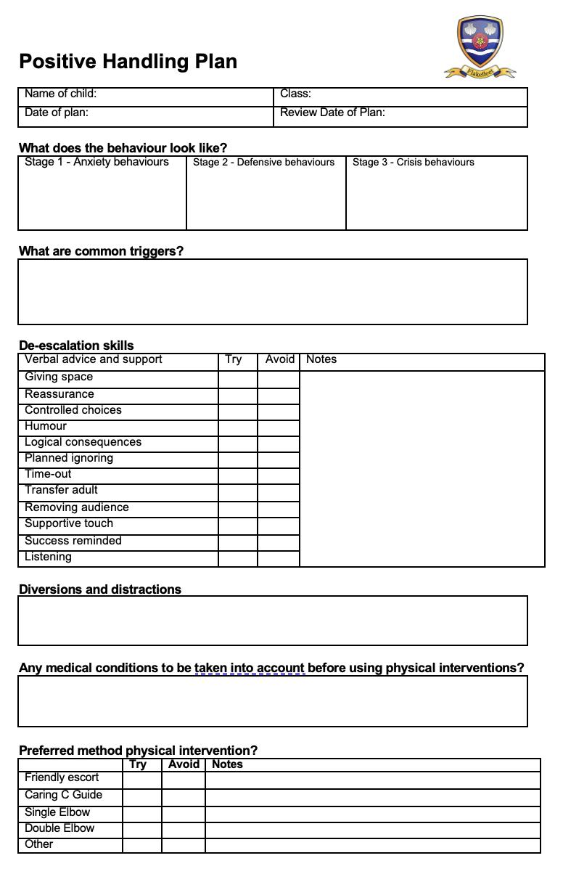

Appendix 4

Support Plan



