Governor Pen Portrait

Name: Greg Baron | Photo: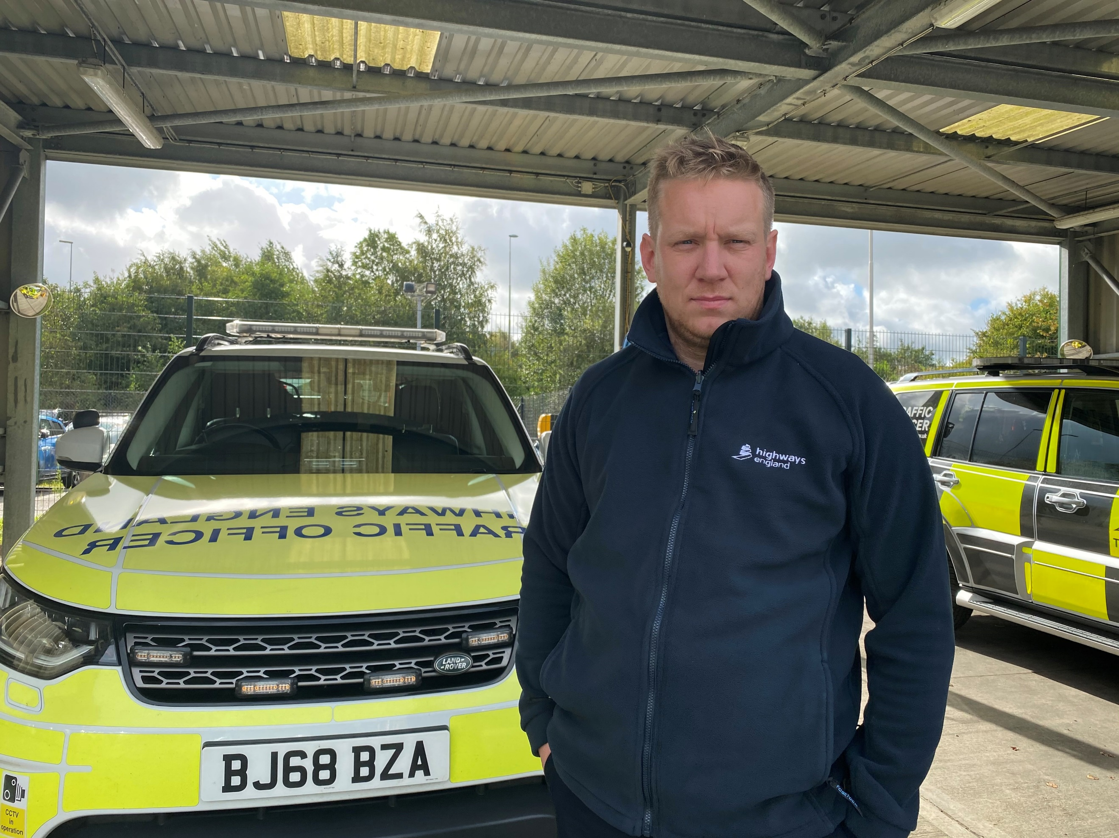
Role on the Governing Body: Website , GDPR / Assessments

Committee’s: SEC

Professional experience/current job role:

Traffic Officer National Highways 15 years –

This is a diverse operational role however since being promoted my main roles are managing officers to ensure the network is clear ,which involves

- Incident management and emergency planning,
- fatal incident reporting and management,
- , inspection regimes, network occupancy, reactive maintenance, planned maintenance, abnormal loads, winter maintenance, damage to network property and the recovery process, ,
- I’m heavily involved with Recruitment for Highways and attend training courses yearly to build my skills ,

- I have Qualified IOSH and First4Safety – I inspect outstations in the north west for slips trips and falls – providing reports and recommendations

- Stakeholder lead – Lancashire Police , Lancs Fire , North West Ambulance customer and stakeholder impacts and liaison, to name a few. holding de briefs

- I control the Rota for Lancashire looking after 46 members of staff ensure we hit our expected Managing performance against targets, performance measures and KPIs, and ensure staff have annual leave and cover for sickness and adverse weather – and ensure within our overtime yearly budget

- Previous to Highways worked Lancashire Constabulary worked in control room managing incidents including multi agency events and major incidents, decision maker and co-ordinator working closely with other organisations, partners and stakeholders, Left Lancs to join Highways

Please explain what your knowledge and experience bring to the role of Governor at St Aidan’s:

For me, I have some knowledge due to my wife working at St Aidans , The staff are a tight team run well with strong leadership from Mrs Finch . I have joined the role as I believe this would be an opportunity to continue to make a difference within the community and also provide my skills in another role other than the transport sector I will help to shape the culture and provide assistance and support to Mrs. Finch. I believe that my management style and energy promotes values and behaviors, which will help all , this is not a short term goal but a long term which we can make St Aidans leading other schools and allow St Aidans to deliver results and most important allow the best chance for the pupils to excel.

