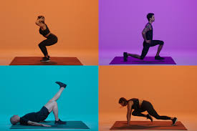
St Aidan’s Exercise Challenge

Can you complete a circuit of activities by doing all the exercises for each letter of your name? If you find it too easy try doing your whole name!

A = 5 x star jumps
B = 2 x tuck jumps
C = 5 x hops on your right leg
D = 10 x squats
E = 3 x burpees
F = 6 x elbow to left knee
G = 5 x touch your toes (straight legs) then reach up high
H = 3 x push ups
I = 5 x hops on your left leg
J = 10 x heel kicks
K = 6 x punches
L = 6 x elbow to right knee
M = 6 x lunges
N = 3 x sit ups
O = 10 x spider crunch
P = 10 second plank
Q = 10 x mountain climbers
R = 10 x bicycle crunch
S = 6 x squat to kick
T = 5 x jump squat
U = 10 x bunny hops
V = 10 second sprint on the spot
W = 10 x star jumps
X = 10 x burpees
Y = 3 x push ups
Z = 10 seconds of high knees

HAVE FUN!!!

