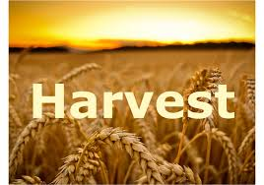

Come and join us in school for our
Harvest Festival!

Friday 11th October @ 9.15am

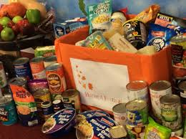
Donations of tins, packet food, dried food would be gratefully appreciated.
All donations will be given to St Aidan’s Church for their food bank.

